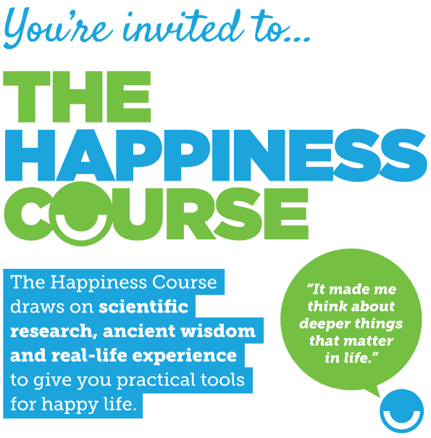
@ The Community Hall, St Silas Church,
Penton St N1 9UL (nr Chapel Market)

Sundays 8th, 15th, 22nd & 29th September
7.00 p.m.

No need to register for this free course, but please let us know you’re coming and/or make enquiries :
020 7837 4228 or e-mail : saintsilas@btconnect.com

