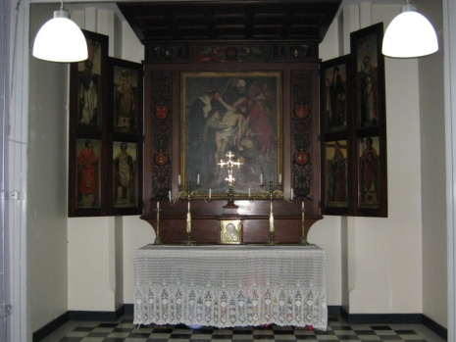

The All Saints Altar in the part of the builing which now forms the Community Hall, was originally in the All Saints Mission. The central piece of the reredos, showing Christ’s removal from the cross, is a 17th or 18th century copy of a painting by Reubens (or someone from his workshop). The side panels, depicting various saints, are by T. Noyes Lewis. The reredos was donated by a group of supporters which included Lady Churchill, widow of Winston Churchill’s uncle.

The remaining ‘highlights’ are outside, and are not shown on the plan

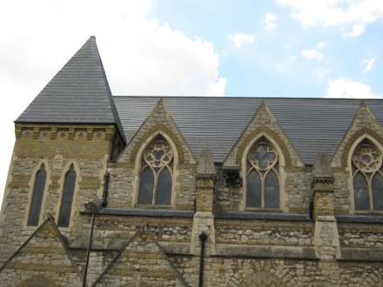

The parish became a pioneer in solar energy in 2010 when the new roof incorporated photovoltaic tiles, which blend with the grey slates. They are best seen by crossing the road from the main doors of the church. The parish received a large grant from the London Borough of Islington, and a government grant towards the cost. Since a government grant had been awarded, the parish is not paid for any additional electricity generated.

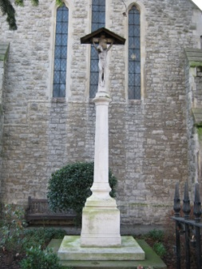

In the garden at the east end of the church there is a WWI memorial. The sculptor was Arthur Walker, whose statue of Florence Nightingale now forms part of the Crimean War Memorial off Wellington Place in central London. The memorial is unusual because it was erected in 1917, before the war had ended.

The Church of St Silas & All Saints
Pentonville

Nine Highlights Self-guided Tour

A leaflet designed to introduce you to some of the architectural features, fittings and furnishings of a church which has served this community for over 150 years.

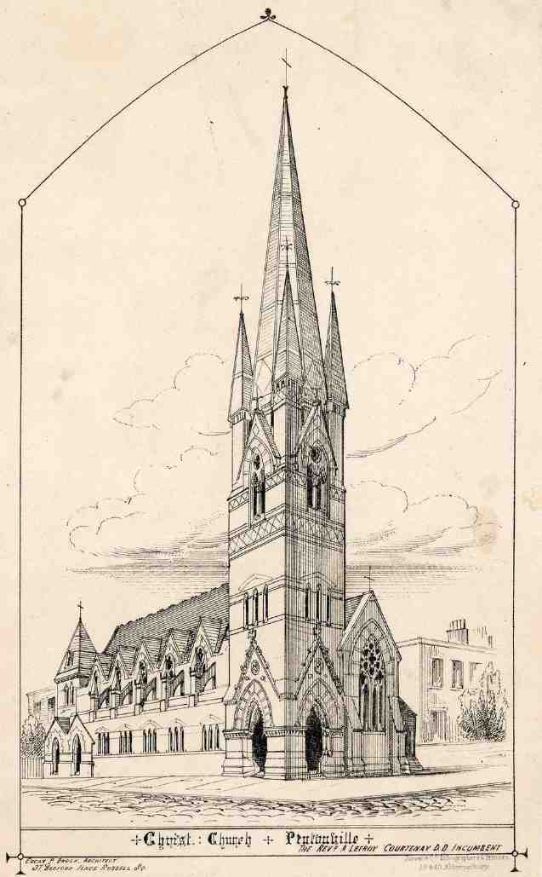

The building now on this site, completed in 1863, replaced a temporary iron building erected in 1860. Originally called Christ Church, it was consecrated as St Silas, Pentonville on 16th July 1867. The church was built on the initiative of the Revd Courtenay, Vicar of St James, Pentonville (now demolished)
The original design by S.S.Teulon was never completed and the original builders were sacked. The updated design by E.Loftus Brock (above) was not completed either, due to a lack of money.

The best place to begin this tour is right in the middle of the church building.
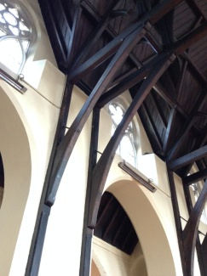 | 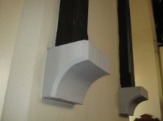
 | 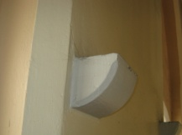

Look up to the roof. The five pairs of double beams are an unusual feature, representing a mid 19th century technical innovation. The roof beams are supported by corbels projecting from the wall. In some places there are corbels supporting nothing. The original church design included galleries on the north and south sides, as well as at the west end, and the corbels might be a remnant of that original intention.

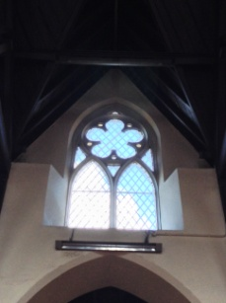

Looking to the upper level of windows, the design of the tracery at the top of each lancet varies. This is characteristic of Teulon’s work. A similar variety of design occurred in the original west window (thought to have been simplified after war damage).

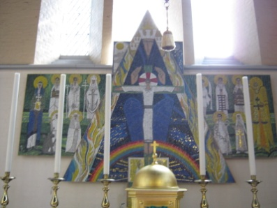

The striking reredos behind the high altar, at the eastern end of the church, designed by Michael Coles was installed in 1994. It is a mosaic made from Venetian glass. The centrepiece depicts the Holy Trinity. The side panels depict various saints.
When the building of the church first started, it extended to Penton St, but the eastern end had to be demolished, since it was built without the right permission. The present chancel was added in 1884.
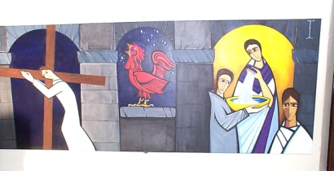

Michael Coles also designed the Stations of the Cross around the building, which tell the story of Jesus’ journey to the cross. They are unusual because the traditional 14 Stations are presented as 7 pairs.

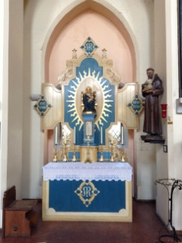

The ornate altar on the north side of the nave houses an image of Our Lady of Walsingham. It was designed by Francis Stephens and paid for by Mr F Russell Brown, an American gin distiller, whose family had originated from this area. He offered much financial support to St Silas. The relationship ended after two communist sons of one of St Silas’ parish priests caused workers at the gin distillery to strike, after visiting America and being horrified by the working conditions.

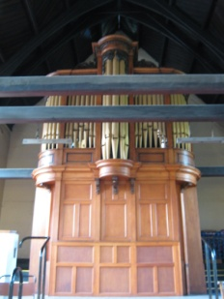

Looking up to the gallery at the west end, you will see the organ case. The organ was built by John Byefield in the mid-18th century and was moved to the church of St Thomas, Regent Street. It was purchased by St Silas in 1966, when St Thomas’ closed. The case is the 1854 case, with extra panels by Thomas Cole of Barnsbury, filling the gap left by the removal of the original console.

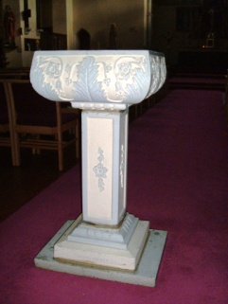

The font at the back of the nave, towards the west doors, is of no architectural significance, but was originally in the All Saints Mission in White Lion Street. It is in memory of Father Preedy, who ran the Mission for 31 years, encouraging the locals in boxing and football. Before moving to London, he had been a founder of Barnsley Football Club in 1891.

