ALMSGIVING

Jesus teaches us that almsgiving is about making the needs of others our own.
This could mean giving up TIME to visit a sick or lonely person, spending more time with our family, or giving practical help to a charity.

We might give up POSSESSIONS by clearing out unused clothes, books etc and donating them to charity.

We might save MONEY and donate it to CARIS ISLINGTON and towards the challenge of helping our parish recover some of the financial loss caused by the Covid-19 pandemic.

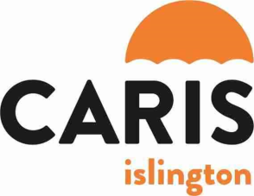

CARIS ISLINGTON runs the Winter Night Shelter and provides free bereavement care for adults & children.

Could you take up this challenge ?

Each day during Lent, remove an item from your home that you no longer use or need and put it aside.
At the end of Lent, donate the things you have collected to a charity shop.

SOME FURTHER DETAILS

Sermons at the 11.00 a.m. Sunday Mass

‘Faith Matters’

21 February : What do you believe in ?

Having Faith

28th February : Walking with God. :

Growing in Holiness

7th March : In the palm of God’s hand :

Prayer

14th March : (Mothering Sunday)

21st March : Come on and celebrate :

Church

28th March : At the heart of Faith :

Death & Resurrection

Stations of the Cross

Due to Covid-19 precautions, we shall not be able to walk Stations of the Cross in the usual way. Here are some ways of reflecting on the Way of the Cross :

Meditations on the Way of the Cross

Mass at 12 Noon on Saturdays will include meditations on the Stations of the Cross.

20 February : Stations 1,2,3

27 February : Stations 4,5,6

6 March: Stations 7,8,9

13 March : Stations 10,11

20 March : Stations 12,13,14

Stations of the Cross on ‘Zoom’

Fr Rayner will lead Stations of the Cross on ‘Zoom’ each Friday during Lent at 7.30 p.m. You will need a Zoom invitation to join in – contact ‘saintsilas@btconnect.com’ if you don’t receive parish e-mails.

Stations on Sundays

Stations of the Cross will take place after Mass on Sundays 28th February and 21st March. Images of the ‘Stations’ will be displayed at the front of the church.

St Silas, Pentonville

with All Saints

Lent

2021

www.saint-silas.org.uk

Parish Priest : Fr Rayner Wakeling

t : 020 7837 4228
e : saintsilas@btconnect.com

Why Lent ?

The Bible tells us that Jesus spent a period of 40 days in the wilderness, preparing for his public ministry.
We spend a period of 40 days preparing for our celebration of Easter. We pay particular attention to the disciplines of prayer, fasting and almsgiving.

Ash Wednesday

Lent begins with Ash Wednesday on
17th February

12 Noon : MASS (said)

7.00 p.m. MASS (said)

At each Mass, ashes will be blessed and sprinkled on the heads of those present
(this year, to replace being marked with the sign of the cross.)
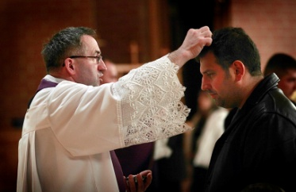

Ash Wednesday is traditionally kept as a day of fasting and self-denial, when we have only one main meal and do not
eat meat.
PRAYER

Pay more attention to your personal prayer. Some suggestions :

- Commit yourself to 15 minutes of prayer each day
- Make use of special Lent booklets
- Spend time in prayerful Bible reading
- Consider making your Confession – make an appointment with
Fr Rayner – full guidance available

Make a greater commitment to communal prayer at church. Some suggestions :

- Attend Mass on Ash Wednesday and all Sundays in Lent. There will be a series of Sunday sermons ; ‘Faith Matters’.
- Attend Stations of the Cross after Mass on Sundays 28th February & 21st March. (or Fridays on ‘Zoom’ ; see below)
- Attend a weekday Mass each week
(with meditations on the Way of the Cross on Saturdays)

Or join us on ‘Zoom’ :
- Fridays @ 7.30 p.m. Stations of the Cross (you’ll need to request a Zoom invitation if you don’t receive parish e-mails : ‘saintsilas@btconnect.com’).

FASTING

The Church asks us to fast on Ash Wednesday and Good Friday. This means having only one main meal. We are also encouraged to abstain from eating meat on Ash Wednesday, Good Friday and all Fridays during Lent.

During Lent you might also fast from :

- A favourite food or drink
- Buying new clothes, jewellery,
CDs or DVDs
- Gossip or dishonesty
- Spending money on entertainment
- One evening of TV per week.

Any TIME you save can be used for prayer, Bible study or practical support for the church or a charity.

Any MONEY you save can be donated through our Smartie Tube Challenge.
Half the money raised will go to CARIS ISLINGTON which runs the Winter Night Shelter and provides free bereavement care for adults & children. The other half of the money will help our parish recover from the financial effects of the Covid-19 pandemic.

