PALM SUNDAY
10th April

We recall Jesus’ triumphal entry into Jerusalem a few days before his death. We hail Our Lord as king, as did the Jews. At Mass we hear the account of the passion, which reminds us the events that will unfold in the coming week.

11.00 a.m.
Procession of Palms
& PARISH MASS
with reading of the Passion.
(Begins in the church garden.)

Monday, Tuesday, Wednesday
in Holy Week

Monday

12.30 p.m. Mass

Tuesday

11.00 a.m. Chrism Mass with the Bishop of Fulham at St Andrew, Holborn

6.15 p.m. Rosary Prayers
6.30 p.m. Mass

Wednesday

12.30 p.m. Mass
MAUNDY THURSDAY
14th April

Today’s liturgy takes us to the Upper Room, where we remember Jesus’ Last Supper with his disciples. At the end of the Mass the Blessed Sacrament is carried to the Altar of Repose, which represents the Garden of Gethsemane. As he prayed before his death, Jesus said to his disciples,
“Could you not watch with me one hour ?”,
so we keep a Vigil of Prayer.

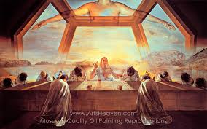

7.00 p.m.
MASS OF THE LAST SUPPER with procession to the
Altar of Repose
followed by a Vigil of Prayer.
8.45 p.m. Night Prayer

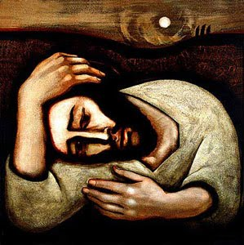
GOOD FRIDAY
15th April

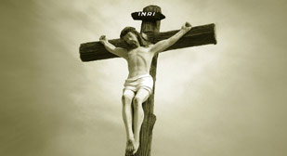

We recall Jesus’ death on the cross.
The church building is quite bare,
so that we are not distracted from our thinking and praying about the events of that day.
The Mass is not celebrated today.

3.00 p.m.
THE GOOD FRIDAY LITURGY OF THE PASSION
with reading of the Passion, Prayers, Veneration of the Cross and Holy Communion.

EASTER EVE
16th April

During the day, the Church waits in anticipation of the Resurrection. Jesus is in the tomb. At the Easter Vigil, readings from scripture recall our salvation history.The Easter Candle is lit from a new fire, and carried into a dark church. The Easter Proclamation is sung. We renew our Baptismal promises and celebrate the First Mass of Easter

7.00 p.m.
THE EASTER VIGIL
& FIRST MASS OF EASTER
with lighting of the Easter Candle

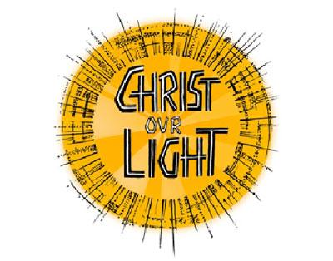

EASTER DAY
17th April

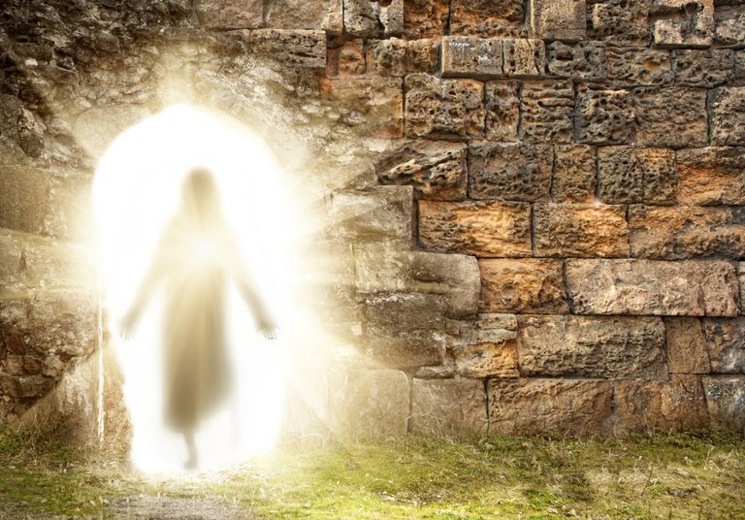

We gather for a joyful
celebration of the resurrection.
The church is
beautifully decorated
and we are full of praise.

11.00 a.m.
FESTIVAL MASS
OF THE RESURRECTION

with Blessing
of Easter Eggs

Alleluia ! Christ is risen !

The Parish Church of St Silas, (with All Saints)
Penton St N1 9UL

(nr Angel Tube & Chapel Market)

HOLY WEEK
& EASTER
2022

We look forward to welcoming you

www.saint-silas.org.uk

Enquiries : 020 7837 4228

