Why not come and join us in .......
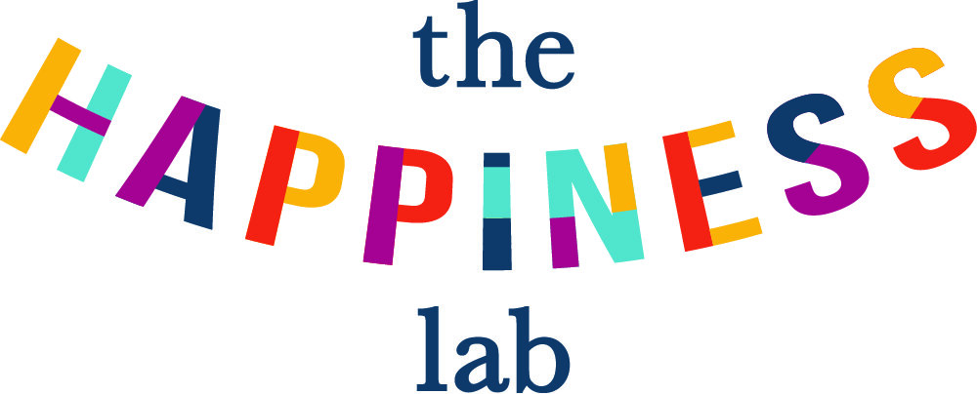

Sundays 12th, 19th, 26th September
2nd, 9th, 16th October 2021 at 6.00 p.m.

The Community Hall @ St Silas’ Church
Penton St N1 9UL

(nr Angel Tube & Chapel Market)

Come and explore what psychologists, doctors and faith leaders say about what makes humans happy.

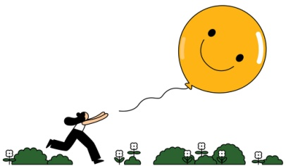
Weekly themes :
Focusing on gratitude and savouring, Practising acts of kindness, Learning to forgive, Investing in friends and family, Looking after your body and soul, Developing coping strategies.

To help planning, please book a free place :
Call 020 7837 4228 or e-mail : saint-silas@btconnect.com

