ALMSGIVING

Jesus teaches us that almsgiving is about making the needs of others our own.
This could mean giving up TIME to visit a sick or lonely person, spending more time with our family, or giving practical help to a charity.

We might give up POSSESSIONS by clearing out unused clothes, books etc and donating them to charity.

We might save MONEY and donate it to CARIS Islington or St Silas Children’s Ministry through our ‘Smartie Tube Challenge’.

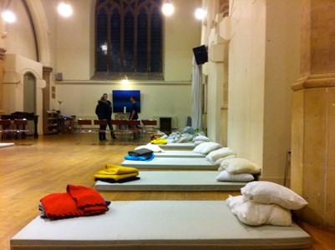

CARIS is a Christian Charity in Islington which organises the Cold Weather Shelter and offers free bereavement counselling to adults and children.

OTHER OPPORTUNITIES

Mass with Ministry of Healing

A Mass with Healing Ministry will take place on Saturday 4th March at 12 Noon.

Benediction of the Blessed Sacrament

Benediction of the Blessed Sacrament will take place on Sunday 5th March at 12.30 p.m. (after the Parish Mass)

Bishop of Fulham’s Lent Stational Mass

The Bishop of Fulham will preside and preach at a Sung Mass at 11.00 a.m. on Saturday 18th March. Soup lunch provided. After lunch there will be silent prayer before the Blessed Sacrament followed by the healing ministries. The afternoon will conclude with Benediction.

‘No Greater Love’

This film, which is a largely observational documentary following a year in the life of a community of nuns in Kensington, will be shown in two halves.

The first half will be after Stations of the Cross on Friday 24th March, the second half after Stations on Friday 31st March.

(We had intended to watch the film last year, but we had some technical issues)

Children’s Activity Afternoon

A Children’s Activity Afternoon will take place on Saturday 1st April from 2.00 p.m. to 5.00 p.m. Further details will be available from church.

Gospel of Matthew by Candlelight

Performer George Dillon will recite Matthew’s Gospel by candlelight on Sunday 2nd April at 7.00 p.m. in church. Tickets £10 (concessions £2.50). Tickets in advance from church (or call 020 7837 4228) or on the door.

St Silas, Pentonville

with All Saints & St James

Lent

2017

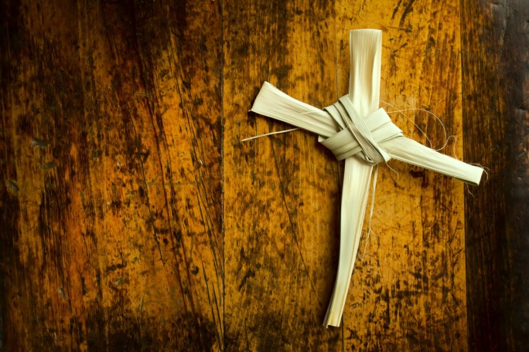

www.saint-silas.org.uk

Parish Priest : Fr Rayner Wakeling

t : 020 7837 4228
e : saintsilas@btconnect.com

Why Lent ?

The Bible tells us that Jesus spent a period of 40 days in the wilderness, preparing for his public ministry.
We spend a period of 40 days preparing for our celebration of Easter. We pay particular attention to the disciplines of prayer, fasting and almsgiving.

Ash Wednesday

Lent begins with Ash Wednesday on
1st March

10.00 a.m. MASS

7.00 p.m. SUNG MASS

At each Mass, ashes made from last year’s Palm Crosses will be blessed and those present are invited to come forward to be marked on the forehead with
the sign of the Cross.

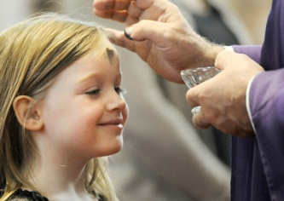

Ash Wednesday is traditionally kept as a day of fasting and self-denial, when we have only one main meal and do not
eat meat.
PRAYER

Pay more attention to your personal prayer. Some suggestions :

- Commit yourself to 15 minutes of prayer each day
- Make use of booklets from church with suggestions for Bible reading and prayer
- Spend time in prayerful Bible reading
- Consider making your Confession – make an appointment with
Fr Rayner – full guidance available

Make a greater commitment to communal prayer at church. Some suggestions :

- Attend Mass on Ash Wednesday
- Attend Mass every Sunday during Lent.
The theme of the sermons at Mass will be ‘God is closer than you think’
- Attend Stations of the Cross (Fridays @ 7pm from 10th March)
- Attend a weekday Mass each week
- Join in the praying of the Rosary (Thursdays @ 5pm)

FASTING

The Church asks us to fast on Ash Wednesday and Good Friday. This means having only one main meal. We are also encouraged to abstain from eating meat on Ash Wednesday, Good Friday and all Fridays during Lent.

During Lent you might also fast from :

- A favourite food or drink
- Buying new clothes, jewellery,
CDs or DVDs
- Gossip or dishonesty
- Spending money on entertainment
- One evening of TV per week.

Any TIME you save can be used for prayer, Bible study or practical support for the church or a charity.

Any MONEY you save can be donated through our Smartie Tube Challenge.
Half the money raised will go to CARIS, a Christian charity in Islington which runs the Cold Weather Shelter and offers free bereavement counselling to adults and children. The other half will be used to support St Silas Children’s Ministry.

Children & families may prefer to support the Backpack Project run by Mary’s Meals, which we have supported before. Collect items for children’s backpacks, which will go to children in some of the world’s poorest nations. Further details from church.

